

Vandalur – Kelambakkam Road

Chennai – 600127

4th semester – 2022

**GYM - TOWN**

**CSE 3002 Internet and Web Programming**

**F2**

Under the guidance of

**Dr. L.M. JENILA LIVINGSTON**

*Report submitted in partial fulfilment of the requirements for the degree of*

Bachelor of Technology (VIT, Chennai)

**By:**

CHIRAG CHANDRASHEKAR 20BAI1298

CICIL MELBIN DENNY J 20BAI1284

JANICE ZIONA ABRAHAM 20BAI1312

**BONAFIDE CERTIFICATE**

Certified that this project report titles **“Gym-Town”** is the bonafide work of “Chirag Chandrashekar, CICIL MELBIN DENNY J, JANICE ZIONA ABRAHAM” who carried the project work under my supervision in the partial fulfilment of the requirements for the J-component of Internet and web programming course.

SIGNATURE

Name of the Guide Guide Registration Number

**DECLARATION BY THE STUDENT**

I **Chirag Chandrashekar** bearing Reg No. **20BAI1298 ,**

hereby declared that this project report entitled **Gym-Town** has been prepared

by me towards the partial fulfilment of the requirements for the award of the

for the J-component of Internet and web programming course under the guidance of

**Dr. L.M. JENILA LIVINGSTON**

I also declare that this project report is my original work and has not been previously submitted for the award of any Degree, Diploma, Fellowship, or other similar titles.

Place: VIT Chennai, 600127

Date: 30-04-2022

* **ABSTRACT**

The purpose of our Fitness Gym Website is to upgrade the existing manual system with the help of computerized equipment’s and computer software, fulfilling their requirements, so that their valuable information can be stored for a longer period with easy accessing and manipulation of the same. The required software and hardware are easily available and easy to work with.

Our Fitness Gym Website, can lead to error free, secure, reliable and fast management system. It can help the user to focus on their other activities rather to concentrate on the record keeping in other words storing and accessing the data. Thus, it will help company in better usage of resources. It can assist the user to concentrate on their other activities. Thus, it will help organization in better utilization of resources and maintain computerized records without redundant entries. Our project also describes how to manage for good performance and better services for the clients.

* **ACKNOWLEDGEMENT**

We wish to express our sincere thanks and deep sense of gratitude to our project guide, Dr. L.M. JENILA LIVINGSTON, Associate Professor Senior SCOPE, for her consistent encouragement and valuable guidance pleasantly offered to us throughout the course of the project work. We are very grateful to her for her support and guidance in completing this project.

We also take this opportunity to thank all the faculty of the school for their wisdom imparted to us throughout the course.

We are thankful to my parents as well. We were able to successfully complete this project with the help of their guidance and support. Finally, we want to thank all my dear friends as well.

Team: The Gym-Town

TABLE OF CONTENTS

04

Abstract

05

Acknowledgement

07

Introduction

08

PROJECT MOTIVE

11

SYSTEM DESIGN

120

METHODOLOTY WITH MODULES

18

SYSTEM SPECIFICATION

20

RESULTS

References

CONCLUSION

FUNCTIONALITY

SCOPE

29

28

09

10

* **INTRODUCTION**

Our Fitness Gym Website been developed to override the problems prevailing in the practicing manual system. Moreover, our system is designed for the particular need of the company to carry out operations in a smooth and effective manner. The application is reduced and made feasible to avoid mistakes while entering the data.

Our website is a user-friendly, and an easy access type protocol been implemented so that each and every one visiting our site can understand the steps for enrolment. Our Fitness Gym Website, as described above, can lead to error free, secure, reliable and fast management system. It can assist the user to concentrate on their other activities rather to concentrate on the record keeping. Thus, it will help organization in better utilization of resources.

Our website consists of Diet plan tips, Work – out Tutorials, Yoga tutorials, Gym facilities and all other basic requirements for a perfect gym management system. Our website provides the user an easy way to access the trainer’s availability slots and the profile access. The trainer’s database is been updated for each and every step been done from the user.

* **PROJECT MOTIVE**

The main objective of our Fitness Gym Website is to manage the details of Gym, Trainer, Member, Facility, Fitness Class. It manages all the information about Gym, Time Slot, Fitness Class, Gym. The purpose of the project is to build an application program to reduce the manual work for managing the Gym, Trainer, Time Slot, Member. It tracks all the details about the Member, Facility, Fitness Class. We made these designs using FIGMA.

We have also made the website in such a way that it is easy to use for the clients and new members can also register themselves to the gym easily and all the management of records and information of the clients can we handled by this website alone and doesn’t need any other code or application.

We have also added many dynamic content to the website so that the users doesn’t find it boring and have introduced various features which are not available in many different gyms.

* **FUNCTIONALITY**

• Provides the searching facilities based on various factors. Such as Gym, Member, Facility, Fitness Class.

• Gym Website also manage the Time Slot details online for Facility details, Fitness Class details, Gym.

• It tracks all the information of Trainer, Time Slot and Facility.

• Manage the information of Trainer

• Exhibits the information and description of the Gym members.

• It deals with monitoring the information and transactions of Facility.

• Integration of all records of fitness blogs.

• Introduction to a new yoga classes.

• Introduction to one-on-one personal class with the trainer of the clients choice.

* **SCOPE**

Our project aims at Business process automation, i.e., we had tried to computerize various processes of Fitness Gym Website. It may help collecting perfect management in details. In a very short time, the collection will be obvious, simple and sensible. It will help a person to know the management of passed year perfectly and vividly. It also helps in current all works relative to Fitness Gym Website. It will be also reduced the cost of collecting the management & collection procedure will go on smoothly. And also, the forms can be easily generated at a time.

• It satisfies the user requirement

• Be easy to understand by the user and operator

• Be easy to operate

• Perfect user interface

• Dynamic content included in the website

• All details of the different blogs, events also included

* **SYSTEM DESIGN (ER DIAGRAM, SYSTEM DIAGRAM)**

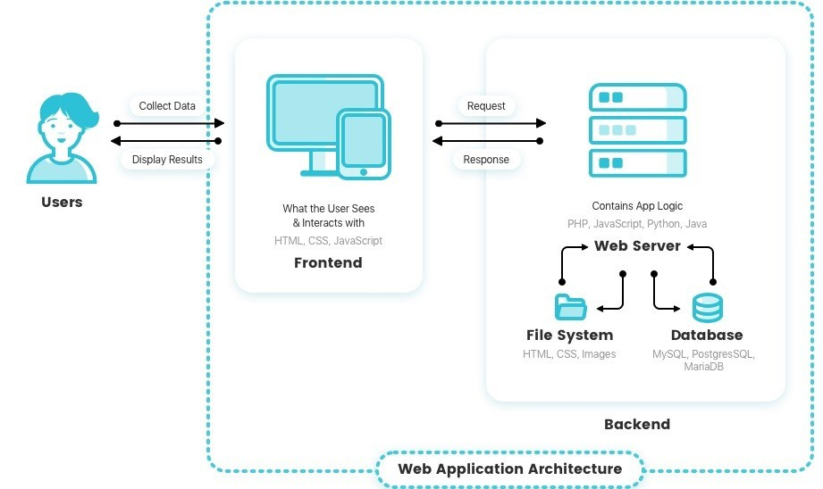

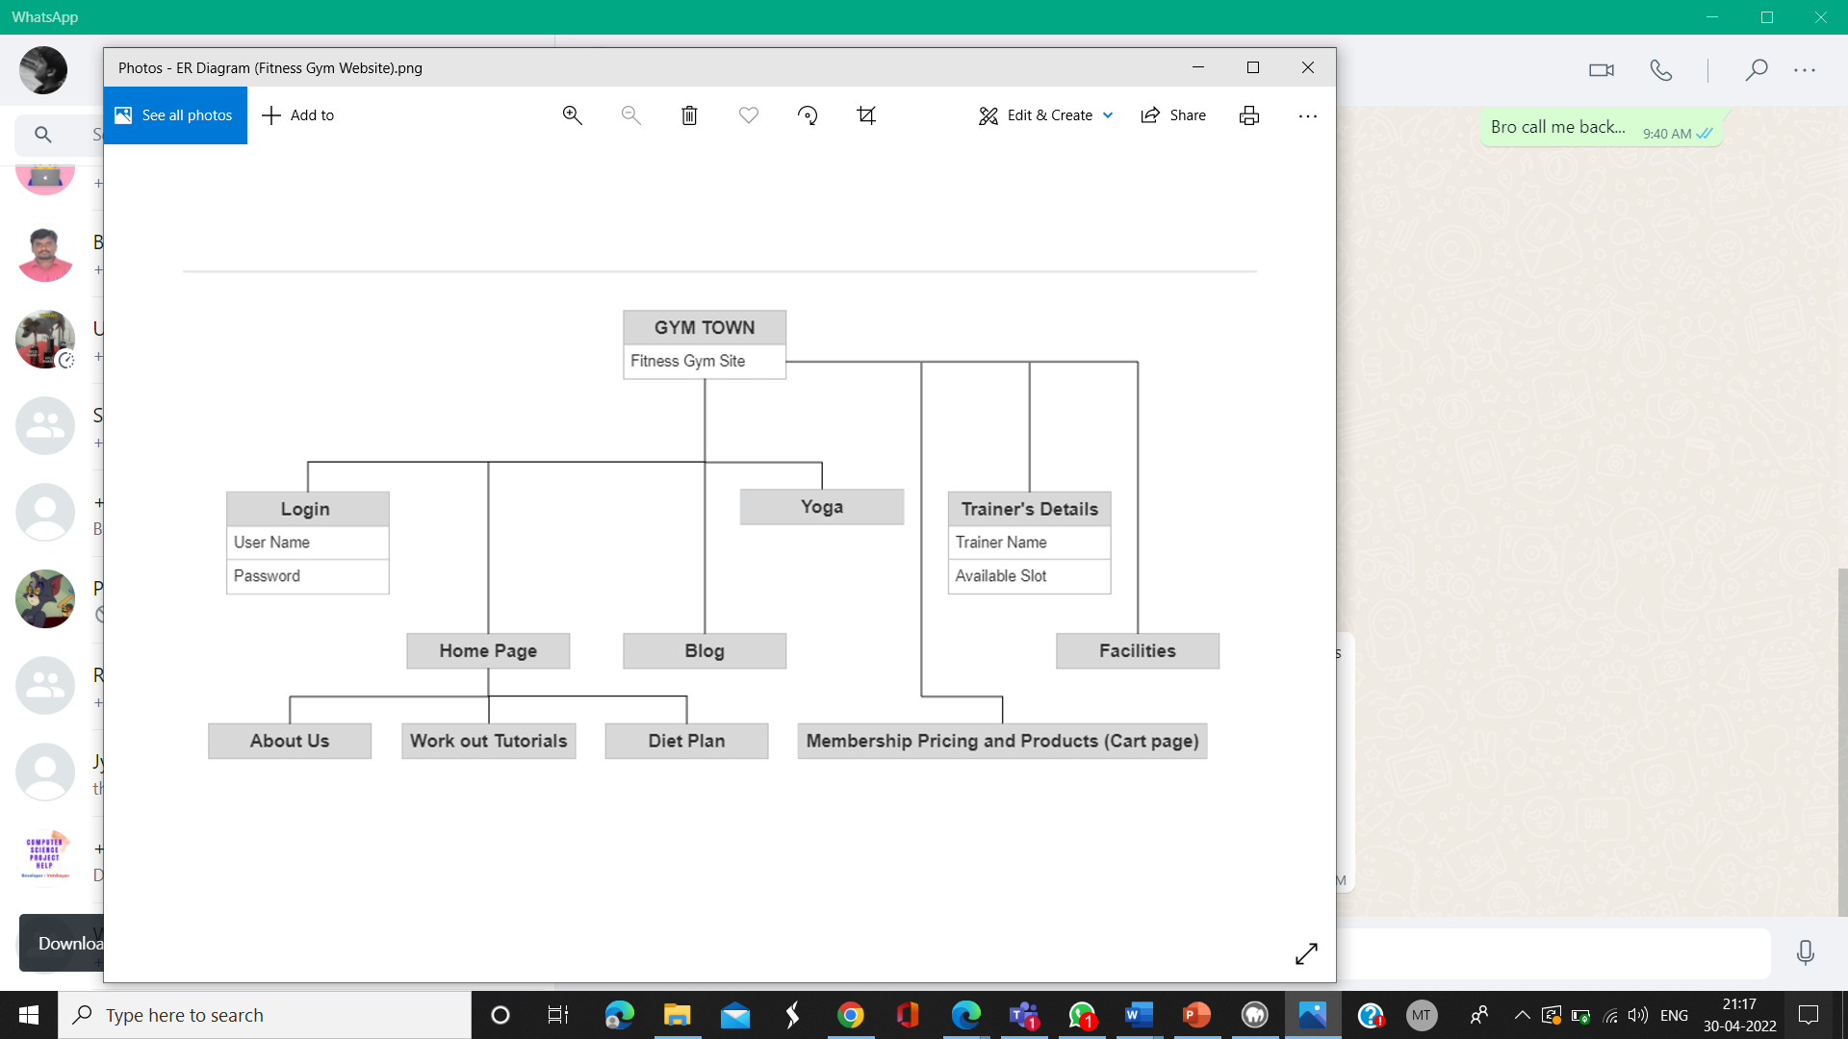

* **METHODOLOTY WITH MODULES**

**MODULES**

* Sign-In
* Log-In
* About-Us
* Product Details
* Member-Ship
* Yoga
* Contact
* Facilities
* Trainer-Details
* Blogs
* **DESCRIPTION OF MODULES**

**Authentication of the user**

1. **Login or Sign Up**

The Gym Website asks for the login form. Here the user enters the User_name and password and the website start the authentication process in which the User_name and password are matched with the current User_name and password in the database.

If the password matches then it is allowed to the main page else it warns the user for Invalid User name and password and directs the user to the sign-up page where they can create a new account which their details would be stored in the database for future use.

After successful authentication the website activates the rest of the features and menus. The activity log also prepared for failures and security.

1. **Gym Details - About Us**

Dashboard – The dashboard is the part of the system where the basic information about the gym is shown. In this project the dashboard displays a brief introduction and some start-up workout plans so that the user can understand about out gym. The dashboard includes details like its history, staff members information, facility, timing and some other feature and information.

Facilities and coach details – Here all the information of the basic facility offered by the gym like the different equipment that are available, locker room, parking area, swimming pool and other facilities are displayed here along with the basic information about the top coaches of our gym. Diet plan and Session Work out details – Here all the basic details as to what exercise and food plan the user must follow in the gym and at home are mentioned, so that the user finds it more convenient to use the gym and achieve their goals.

1. **Products and Member-Ship**

Here all the different plans that the gym offers are displayed along with the various nutrition products such as protein supplements along with the different workout equipment are listed so that users are able to get the required products at a low a cost. And also there is separate page made for member-ship details along with the cost of each of them along with a count-down time for any offer to end.

The Member Pricing page in our website allows the user to unlock the gym facilities offered by GYM TOWN. Every membership plan is unique and helps the user to choose the membership offer that is perfect for them. The product page in our website allows the members to buy our custom-made gym products which supports our gym facility and encourages our members to buy our products that is perfectly designed to their liking. Once the user checks out the product/membership pricing page it will immediately take them to the cart page where the user can check out their product/membership plans by paying their money through internet banking/credit/debit cards.

1. **Yoga**

And also, we’d added a new and a unique which tries to track the user’s workout plan and predict their emotion status and also displays a list of therapy doctors that a user can view and book an appointment. The main reason to introduce this module is because it is believed that a person can be physically fit only if he is mentally fit at the same time.

1. **Contact Page**

In this page we mention various details regarding out gym like the contact details fast free trial class registration form, different branch where our gym is located and various other features like the different events conducted by the gyms along with some details of the trainers and facilities available.

1. **Facilities**

This page has been created to give an overview about our gym, the facilities and the fun perks that our gym offers to our customers. This includes the events that

are being conducted, infrastructure of the gym that are being offered to our customers.

1. **Trainer details**

The trainer details are also added to our website so that the user will be able to see the trainer personal details and contact information this enables our user to the see the slot timings of the trainer and book their sessions. This feature makes the slot booking easier for the user, which enables them to have their workouts sessions seamlessly.

1. **Blogs**

Gym blog page as also been enabled in our website which allows our customers and trainers to share their experiences and tips regarding the gym facilities and diet plans. This helps our customers to reach their workout goals in a short period of time.

* **SYSTEM SPECIFICATION**

The function and performance allocated to the website as part of system engineering are refined by establishing a complete information description, a detailed functional and behavioral description, an indication of performance requirements and design constraints, appropriate validation criteria.

**The Proposed System has the following Requirements:**

• System needs store information about new entry of Gym.

• System needs to maintain quantity record. System also needs a search area. It also needs a security system to prevent data.

• System needs to help the internal staff to keep information of Trainer and find them as per various queries.

• System needs to keep the record of Member. System needs to update and delete the record.

**Technical Details**

• Data base - The System shall use the MySql Database, which is open-source file.

• Operating System - The development environment should be window 7 as well as windows 8 Web Based - The system shall be web-based application. Coding platform – Html, CSS along with JavaScript.

• HARDWARE REQUIREMENT

o Processor: Intel P-IV System

o Processor Speed: 833 MHz

o Ram: 512 Mb Ram

o Hard Disk: 40 Gb

• SOFTWARE REQUIREMENT

o Operating System: Windows 2000

o Professional Environment: Notepad++

o Net Framework: Version 1.0

o Language: HTML, CSS, JavaScript

o Backend: SQL Server 2000

* **RESULTS (WITH SCREENSHOTS)**

**Home Page**

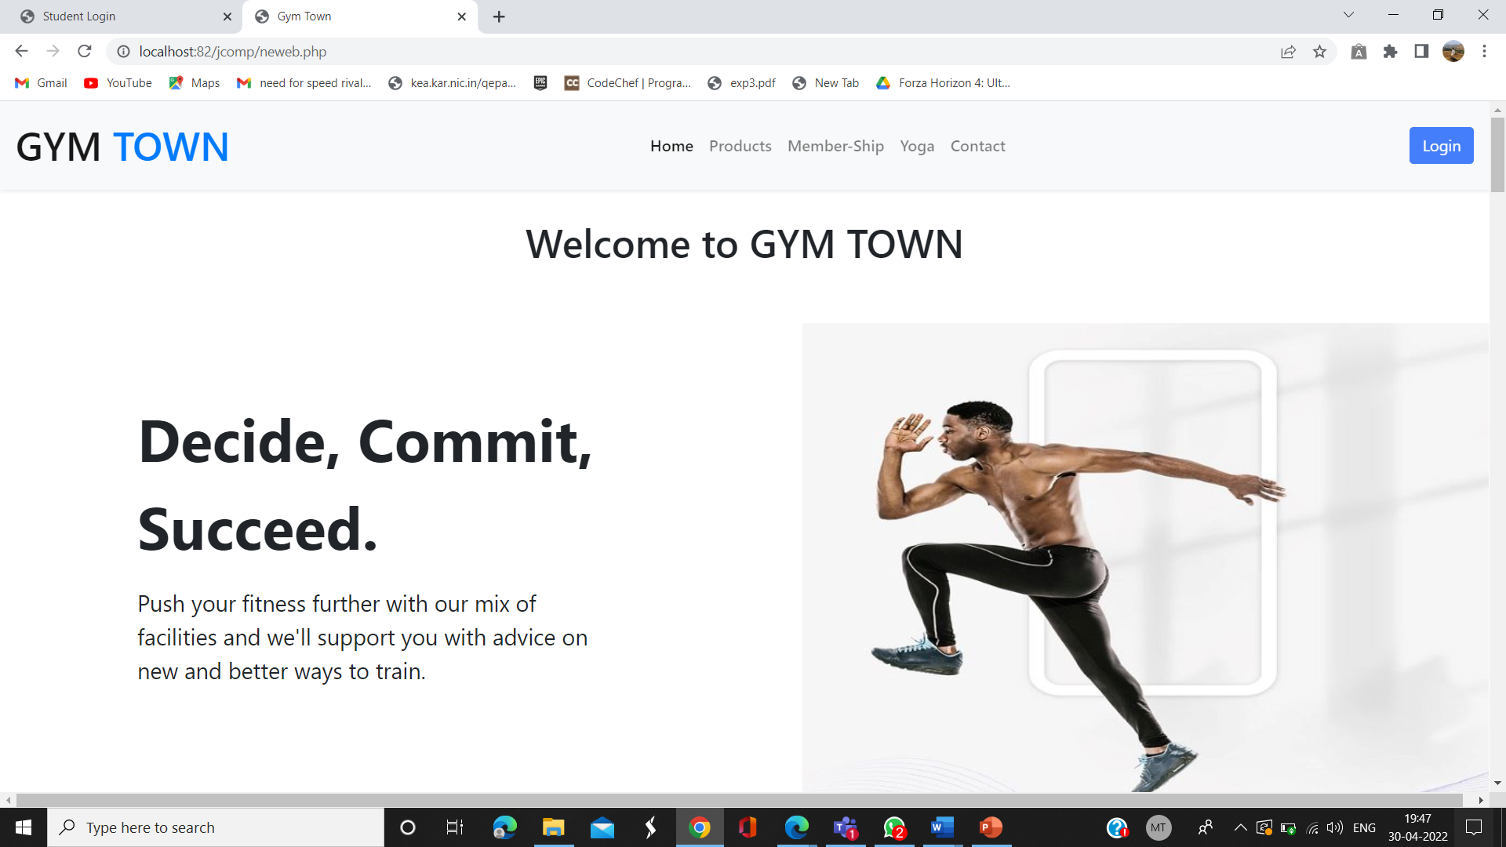

**Login Page**

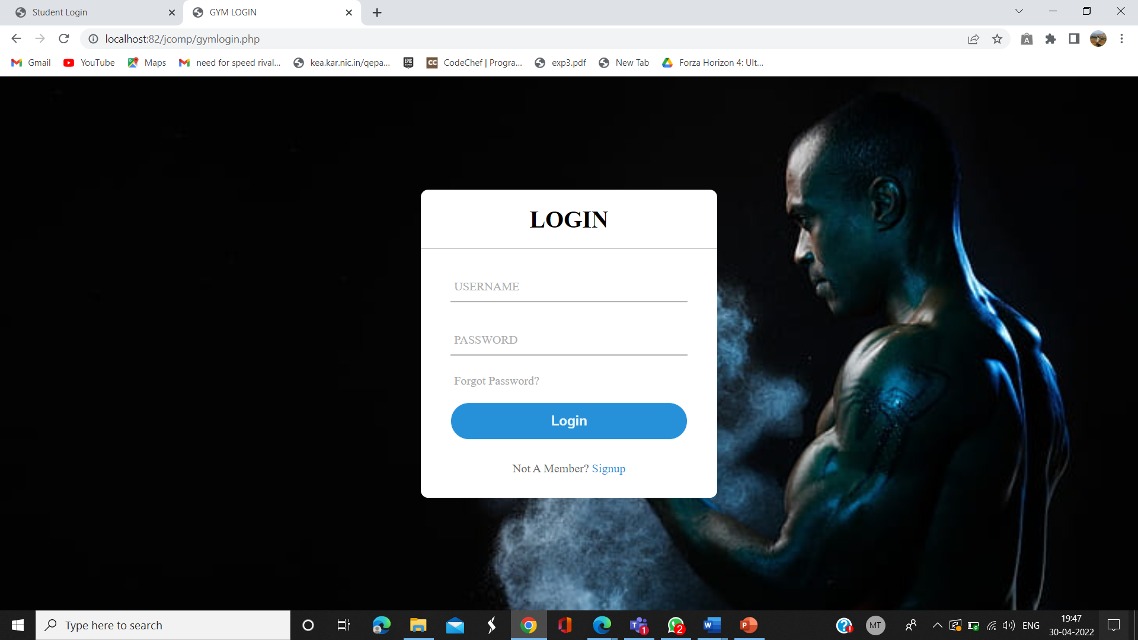

**Sign in Page**

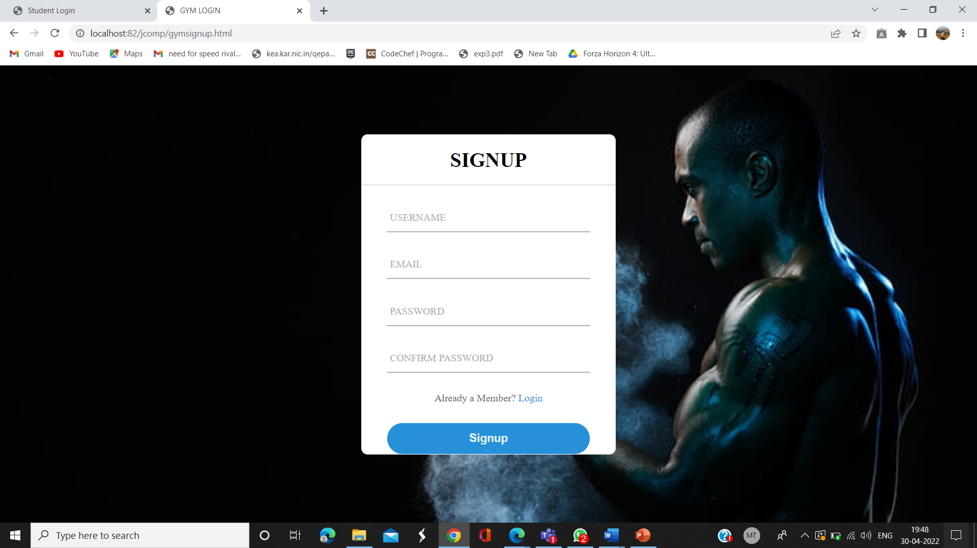

**Home page after login**

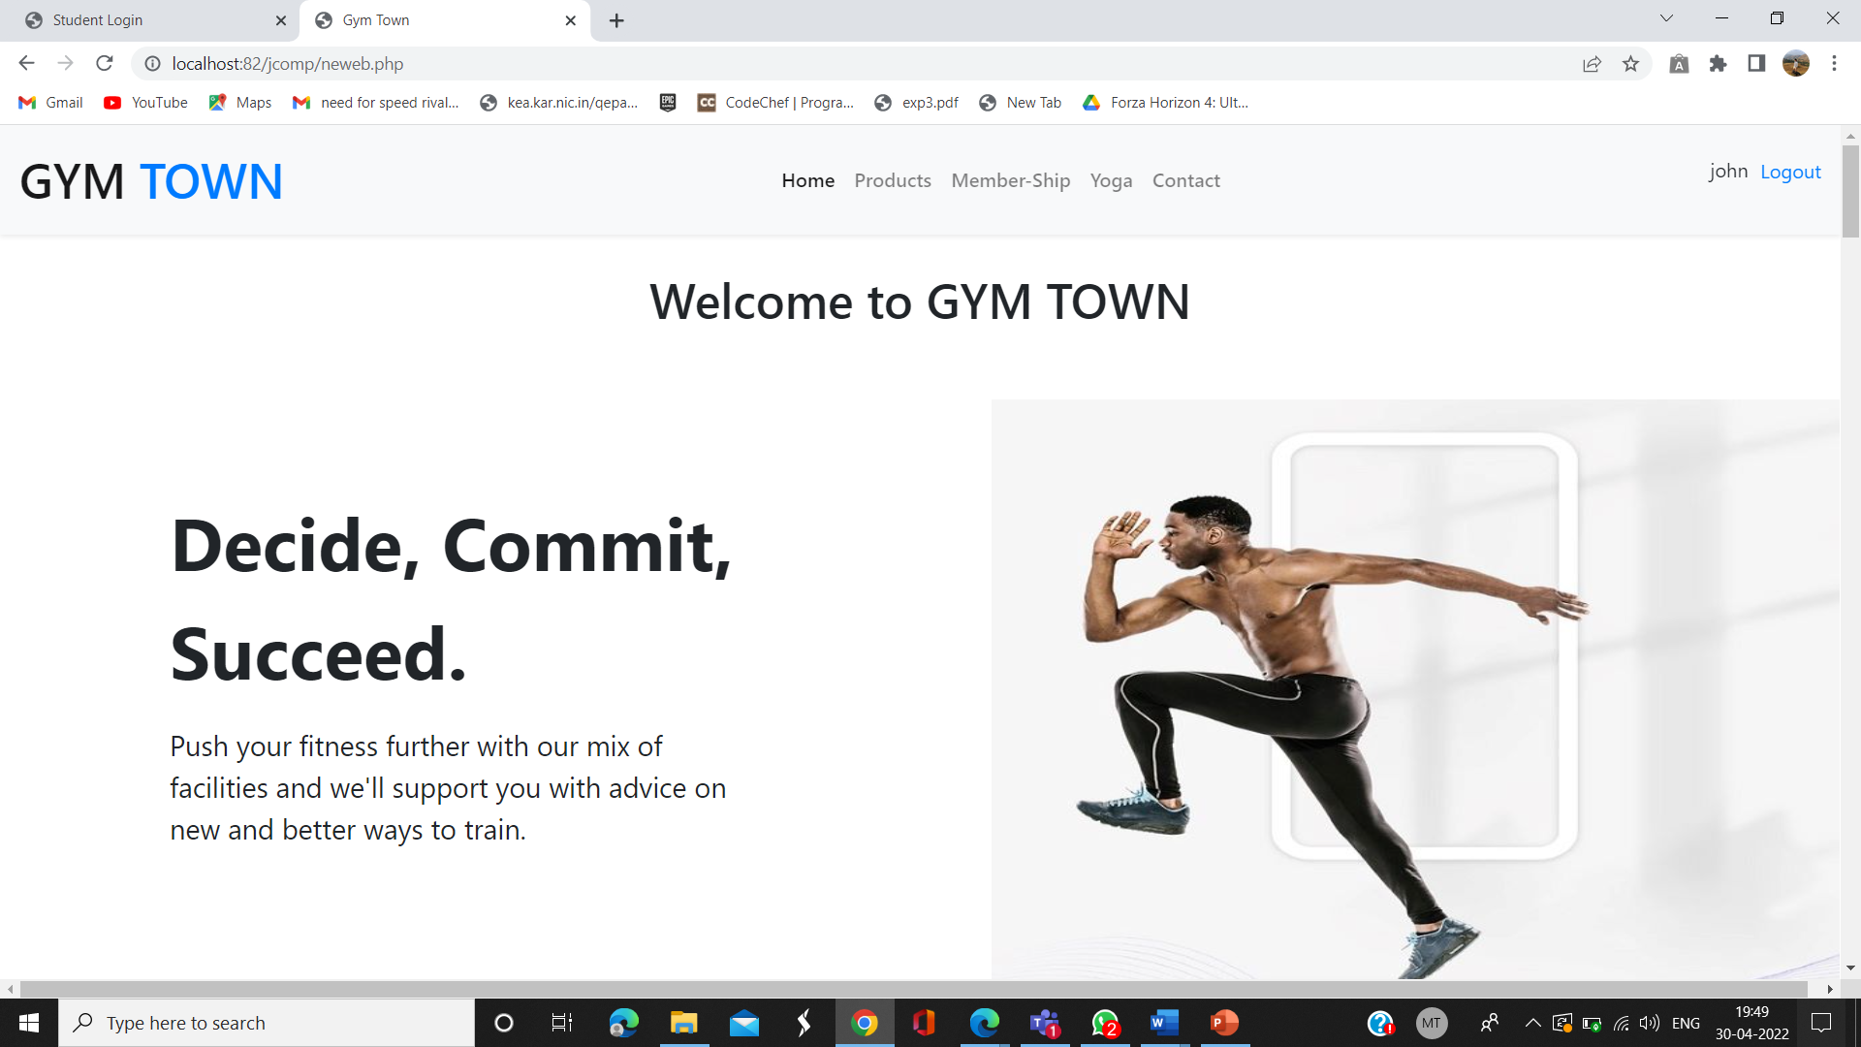

**Product Page**

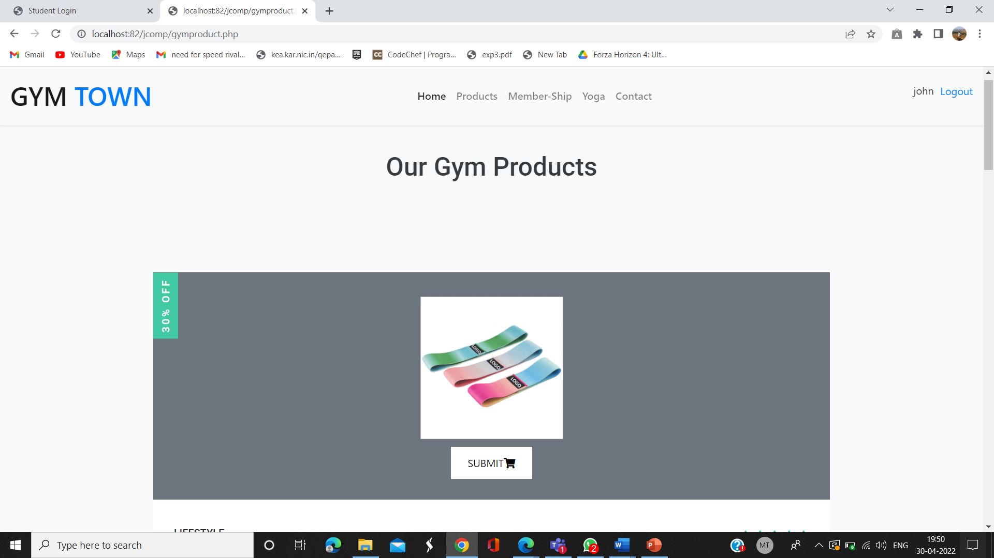

**Member-Ship page**

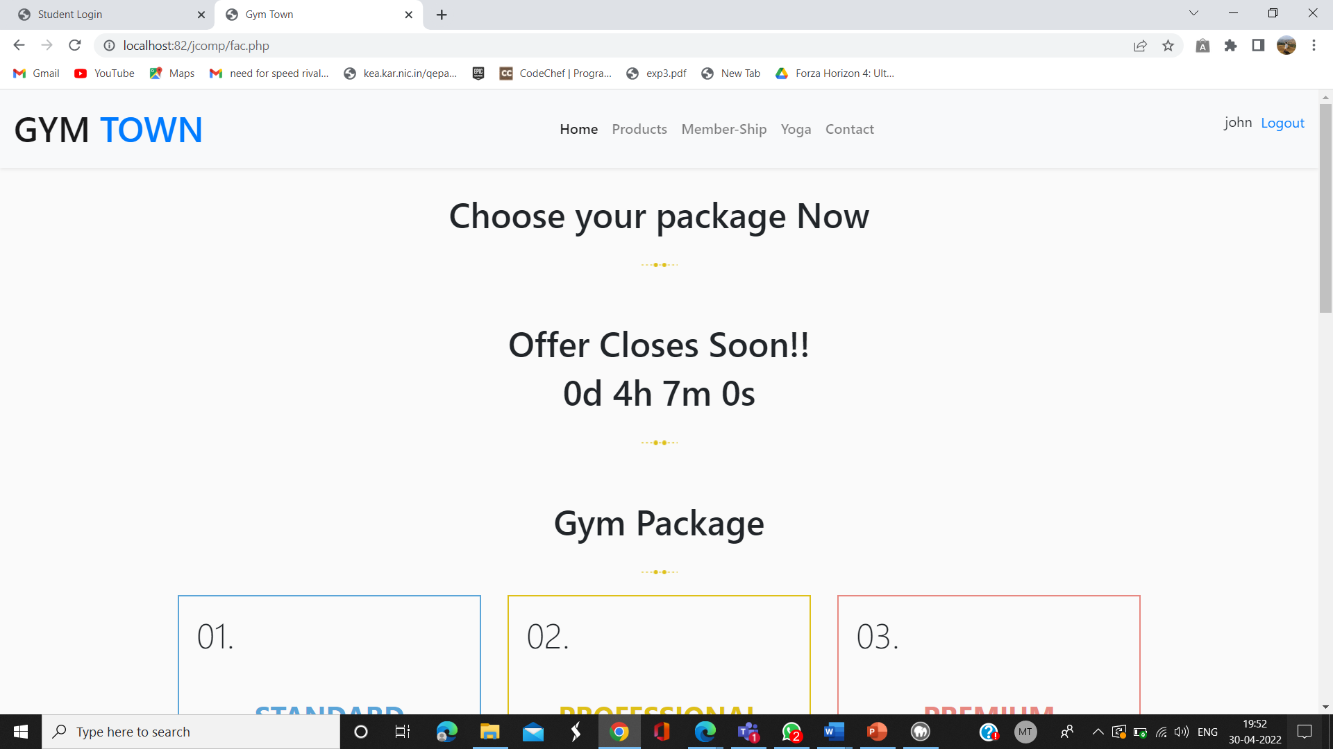

**Yoga Page**

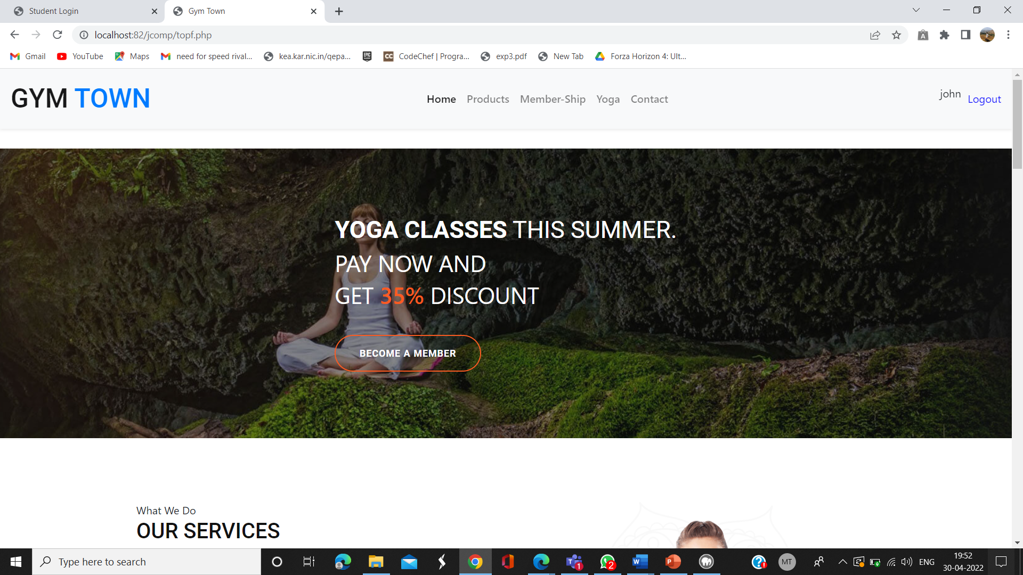

**Gym Details page**

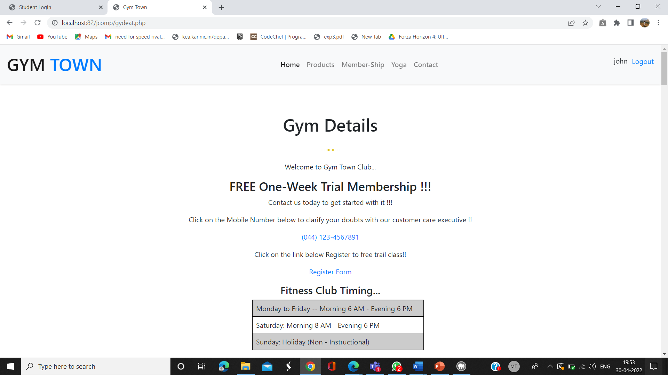

**Facilities page**

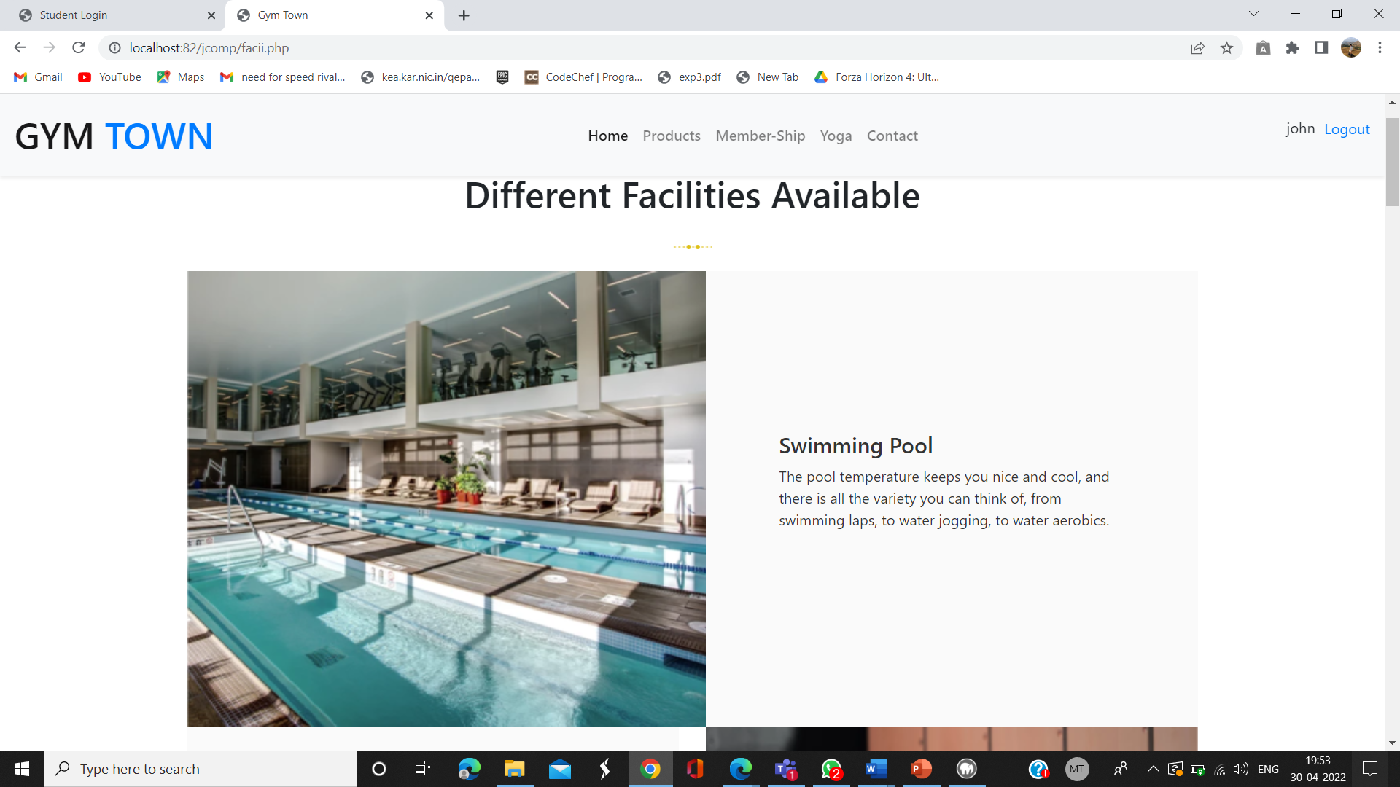

**BMI Calculator page**

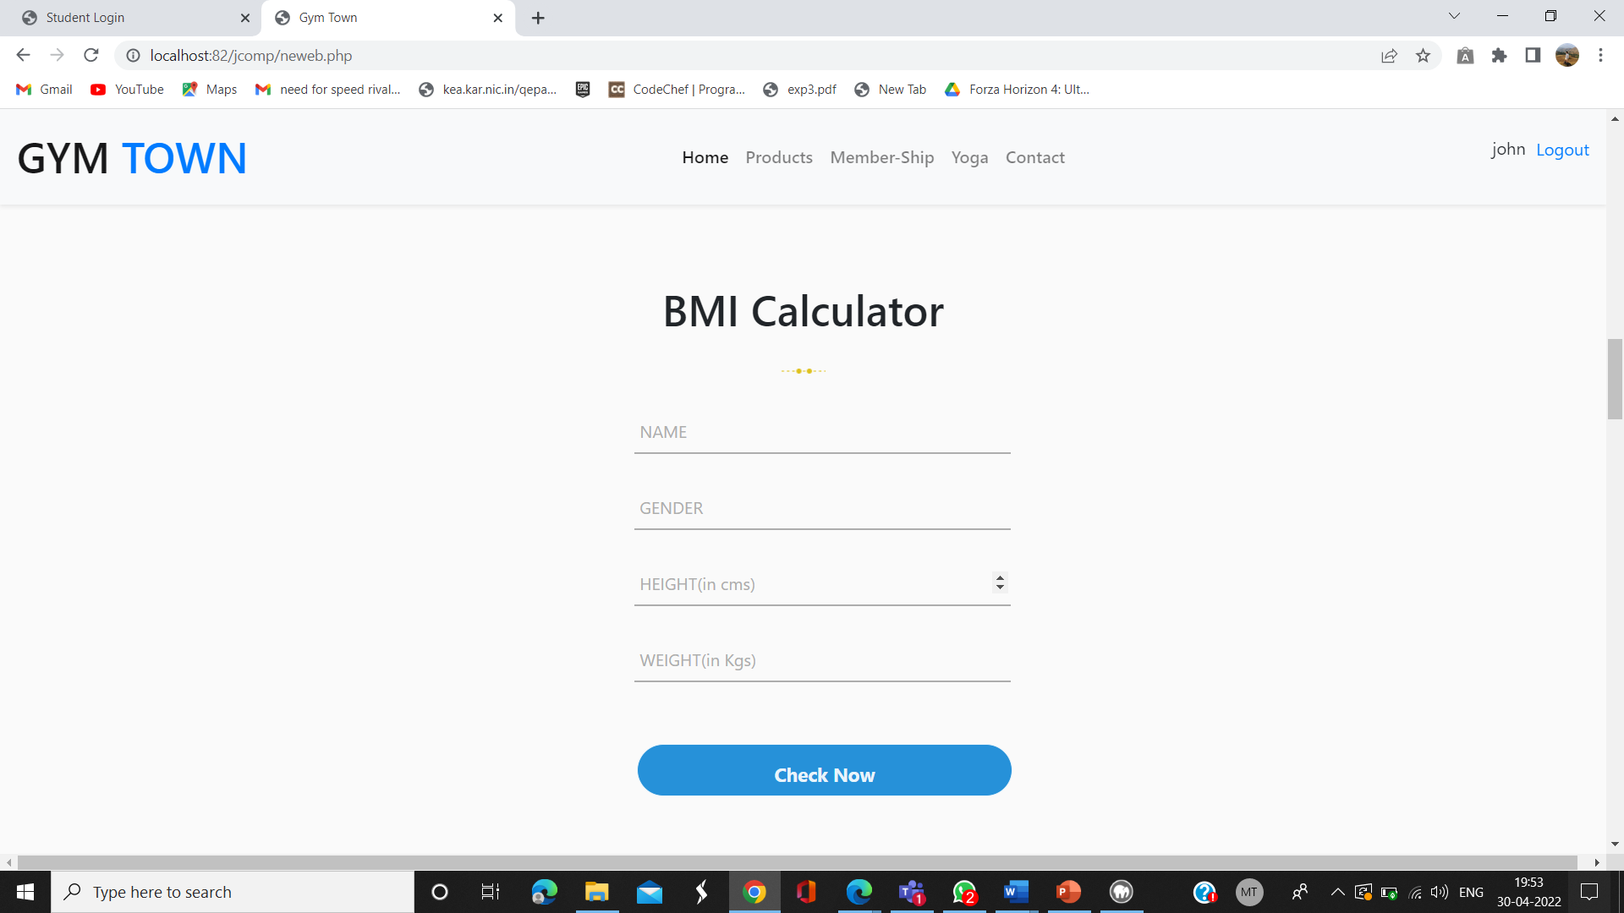

**Trainer Details page**

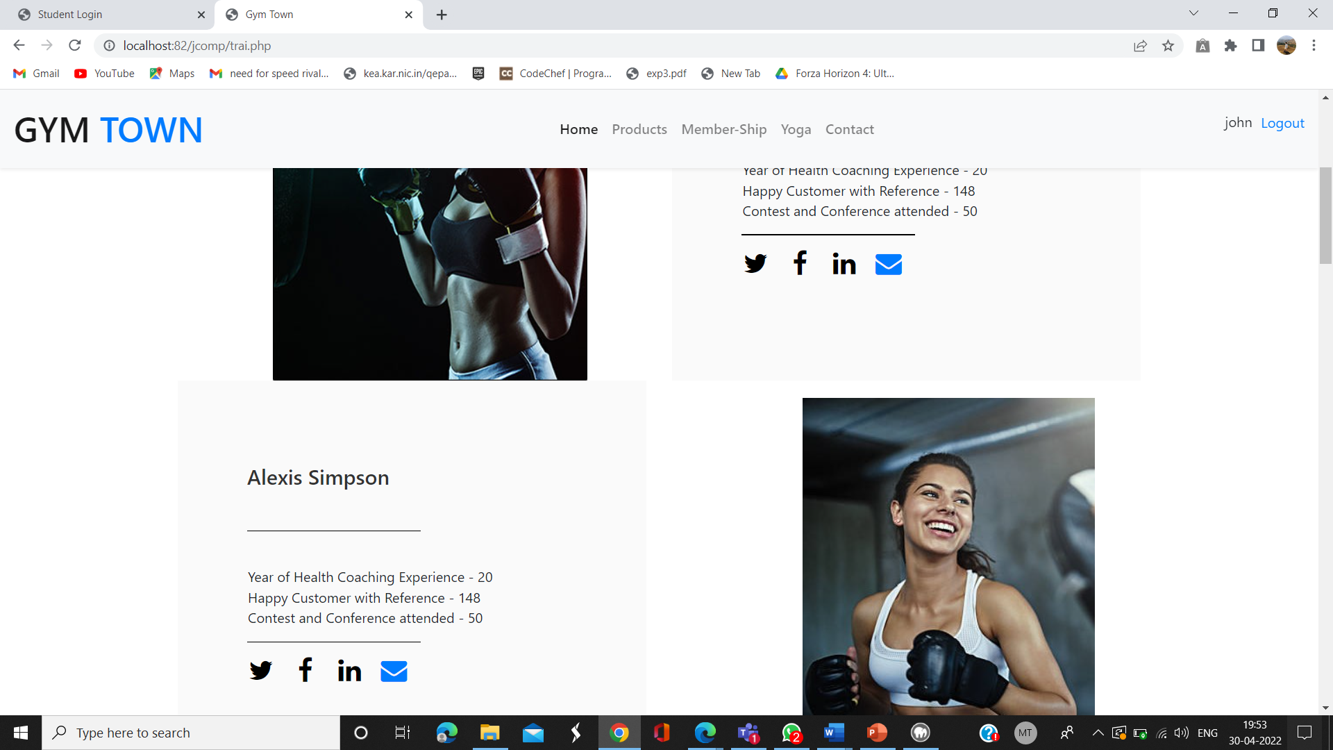

**Blog Details page**

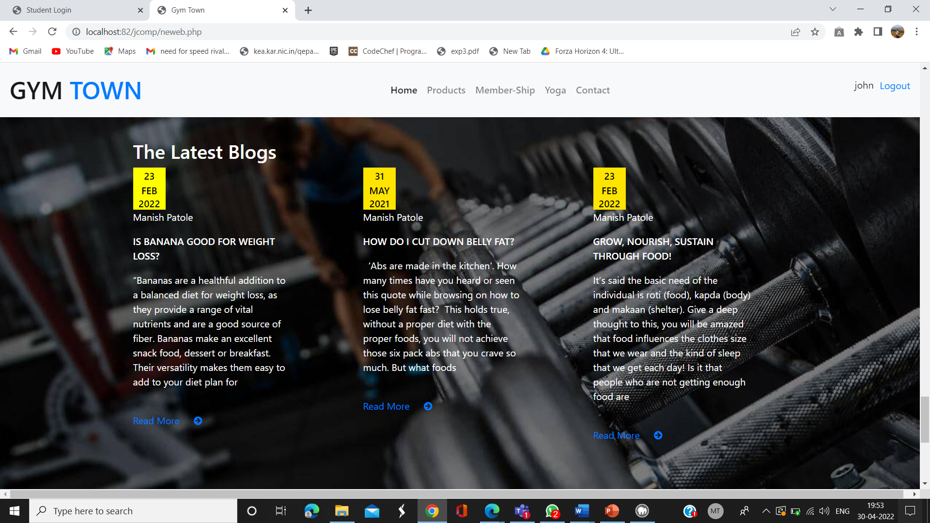

**Blog page**

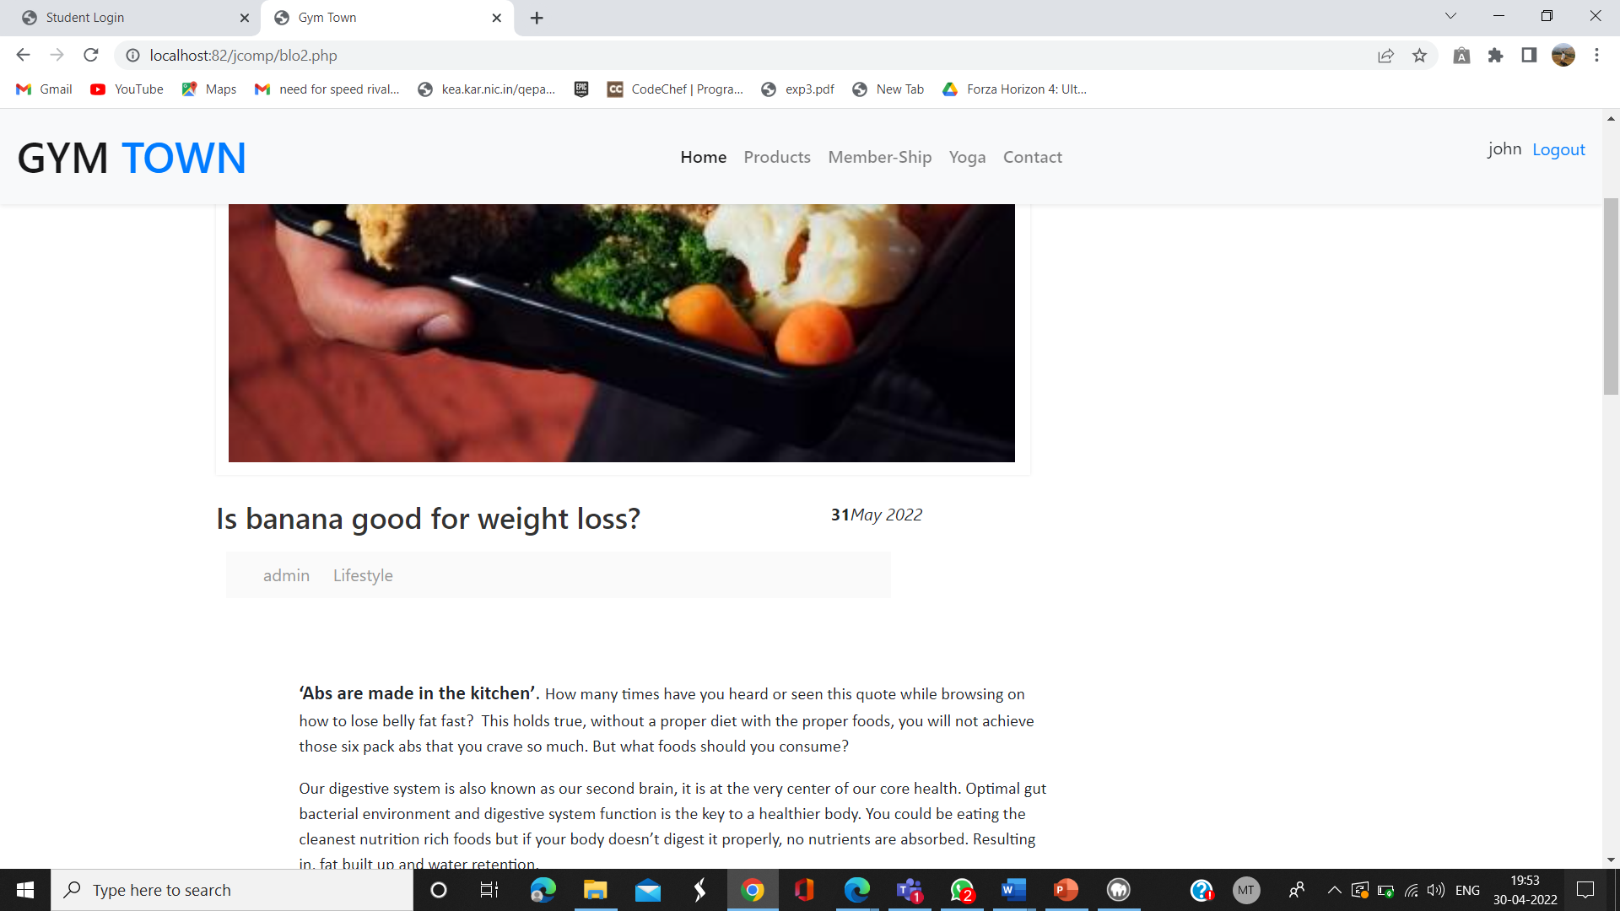

**Events page**

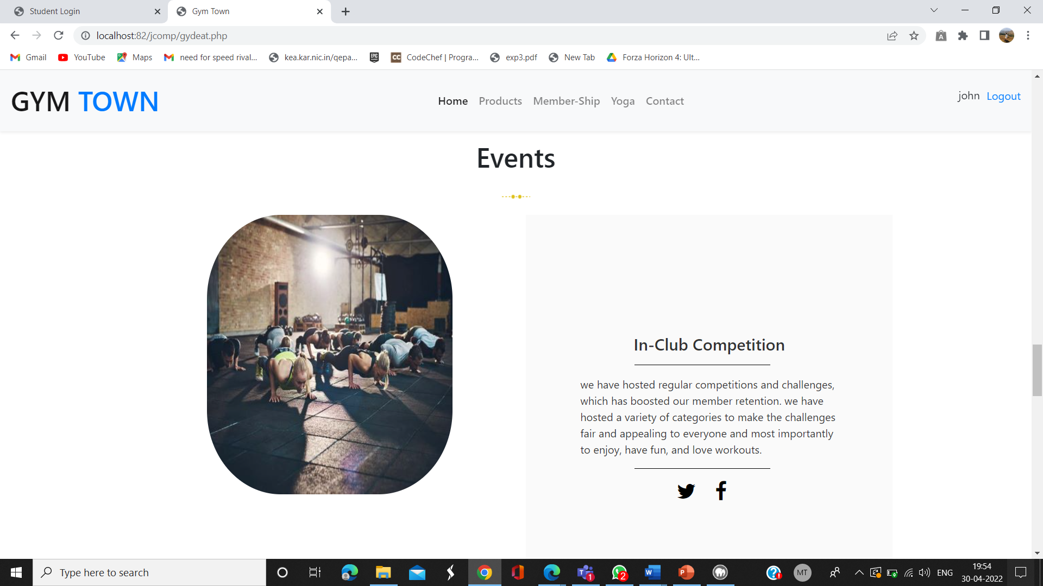

**Cart page**

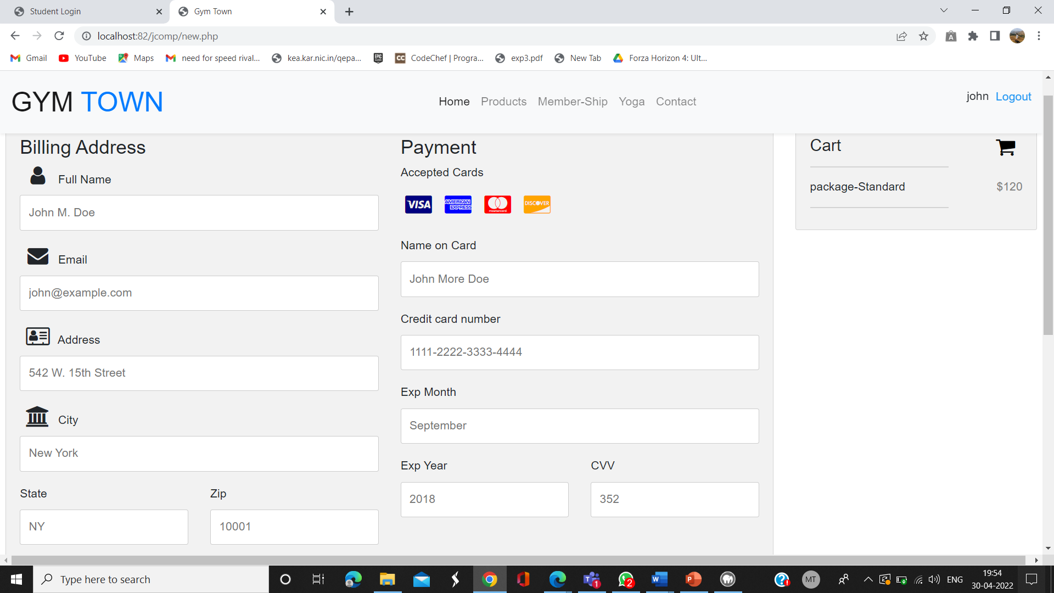

**Billing page**

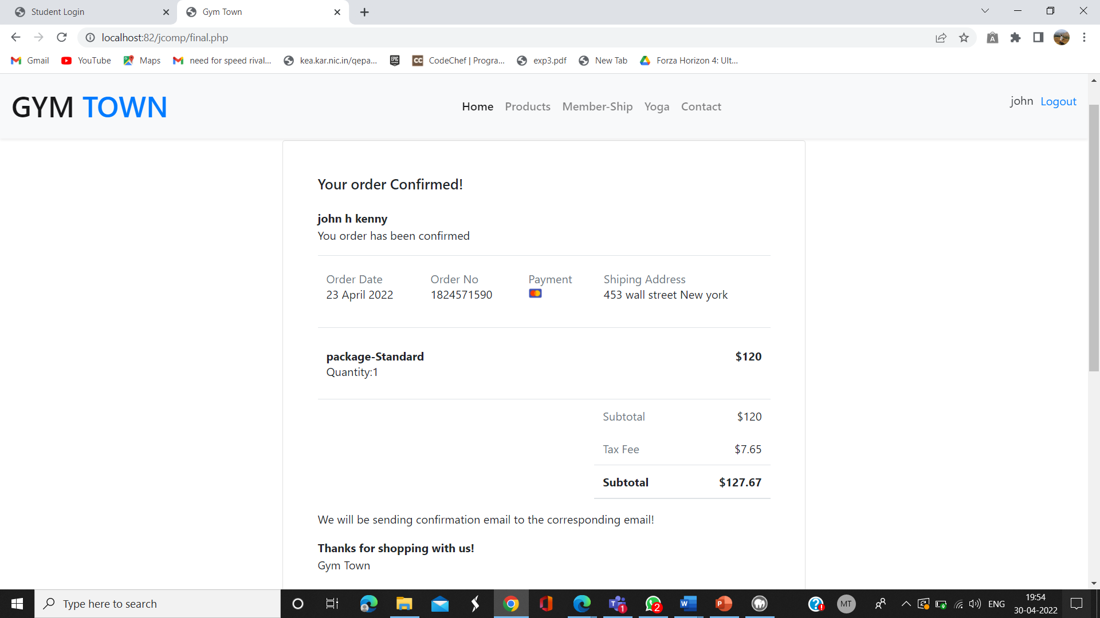

* **CONCLUSION**

Our project main motive is to satisfy the needs of our customers in lowering their works in booking their fitness trainer and getting into their diet plans, training schedules, etc., Thus, it will help organization in better utilization of resources and maintain computerized records without redundant entries.

Our Fitness Gym Website, can lead to error free, secure, reliable and fast management system. It can help the user to focus on their other activities rather to concentrate on the record keeping in other words storing and accessing the data. Thus, it will help company in better usage of resources. It can assist the user to concentrate on their other activities. Our project also describes how to manage for good performance and better services for the clients.

* **References:**
  1. <https://www.w3schools.com/html/>
  2. <https://www.w3schools.com/w3css/defaulT.asp>
  3. <https://www.w3schools.com/php/>
  4. <https://www.w3schools.com/php/php_mysql_intro.asp>